

**Digital Logic Lab Assignment 12**

**BCD TO DECIMAL DECODER**

**SUBMITTED BY:**

Gaurav Chaulagain

Year I / SEM I

017BSCIT014

**SUBMITTED TO**

|  |  |
| --- | --- |
| Er. Saugat Sigdel  Lecturer |  |
| Department of Computer Science | |

**OBJECTIVE 12**

**TO VERIFY THE OPERATION OF BCD TO DECIMAL DECODER**

**THEORY:**

The **BCD-to-decimal decoder** converts each BCD code to its decimal equivalent. The technique employed is very similar to the one used in developing the 4-line-to-16-line decoder.

**TRUTH TABLE:**

|  |  |  |  |  |  |  |  |  |  |  |  |  |  |  |
| --- | --- | --- | --- | --- | --- | --- | --- | --- | --- | --- | --- | --- | --- | --- |
| BCD | | | | Decimal | | | | | | | | | | |
| W | **X** | **Y** | **Z** | **D0** | **D1** | **D2** | **D3** | **D4** | **D5** | **D6** | **D7** | **D8** | **D9** |
| 0 | 0 | 0 | 0 | 1 | 0 | 0 | 0 | 0 | 0 | 0 | 0 | 0 | 0 |
| 0 | 0 | 0 | 1 | 0 | 1 | 0 | 0 | 0 | 0 | 0 | 0 | 0 | 0 |
| 0 | 0 | 1 | 0 | 0 | 0 | 1 | 0 | 0 | 0 | 0 | 0 | 0 | 0 |
| 0 | 0 | 1 | 1 | 0 | 0 | 0 | 1 | 0 | 0 | 0 | 0 | 0 | 0 |
| 0 | 1 | 0 | 0 | 0 | 0 | 0 | 0 | 1 | 0 | 0 | 0 | 0 | 0 |
| 0 | 1 | 0 | 1 | 0 | 0 | 0 | 0 | 0 | 1 | 0 | 0 | 0 | 0 |
| 0 | 1 | 1 | 0 | 0 | 0 | 0 | 0 | 0 | 0 | 1 | 0 | 0 | 0 |
| 0 | 1 | 1 | 1 | 0 | 0 | 0 | 0 | 0 | 0 | 0 | 1 | 0 | 0 |
| 0 | 0 | 0 | 0 | 0 | 0 | 0 | 0 | 0 | 0 | 0 | 0 | 1 | 0 |
| 1 | 0 | 0 | 1 | 0 | 0 | 0 | 0 | 0 | 0 | 0 | 0 | 0 | 1 |
| A-F Don’t care | | | | | | | | | | | | | | |

**Expression:**

D0 = W’X’Y’Z’ D1 = W’X’Y’Z D2 = X’YZ’ D3 = X’YZ D4 = XY’Z’

D5 = XY’Z D6 = XYZ’ D7 = XYZ D8 = X’Y’Z’ D9 = WZ

**CIRCUIT DIAGRAM:**

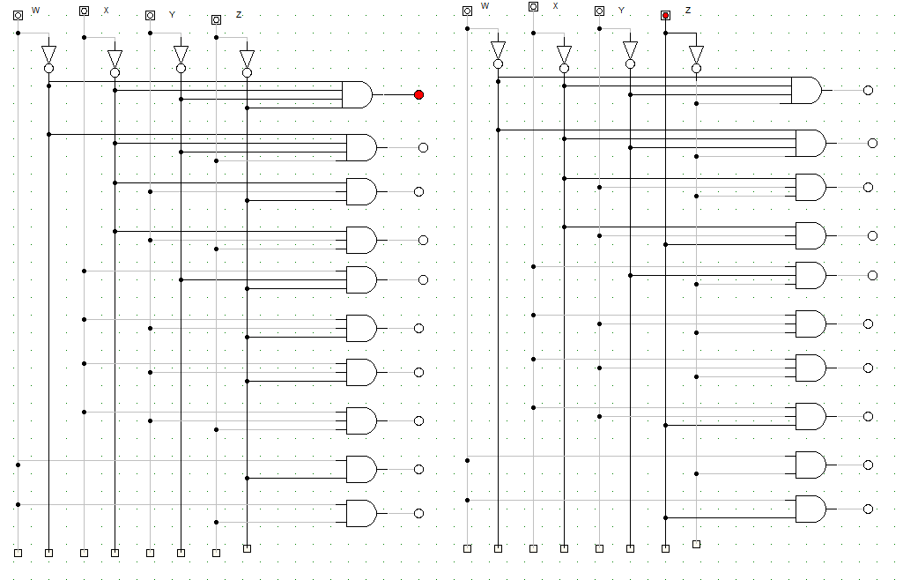

**OBSERVATION:**



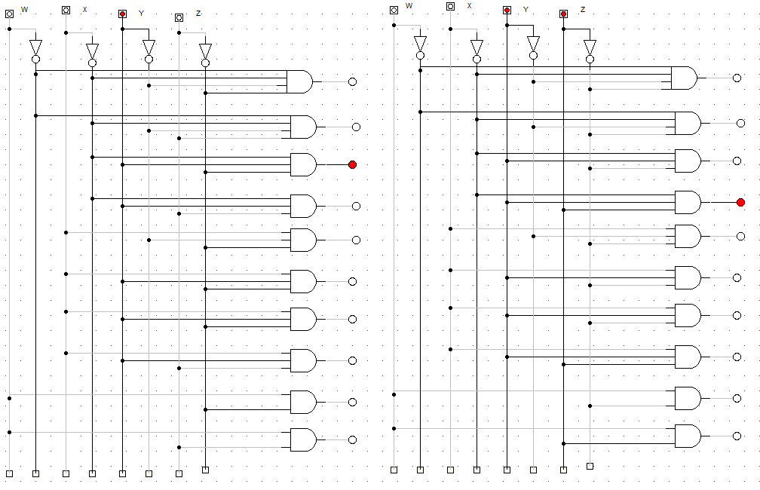

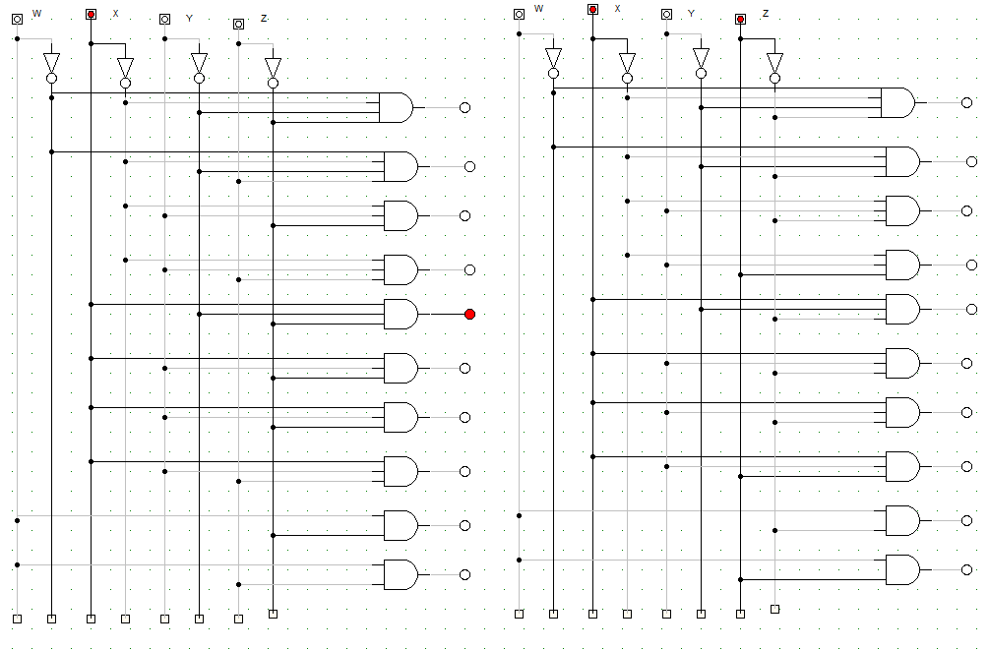

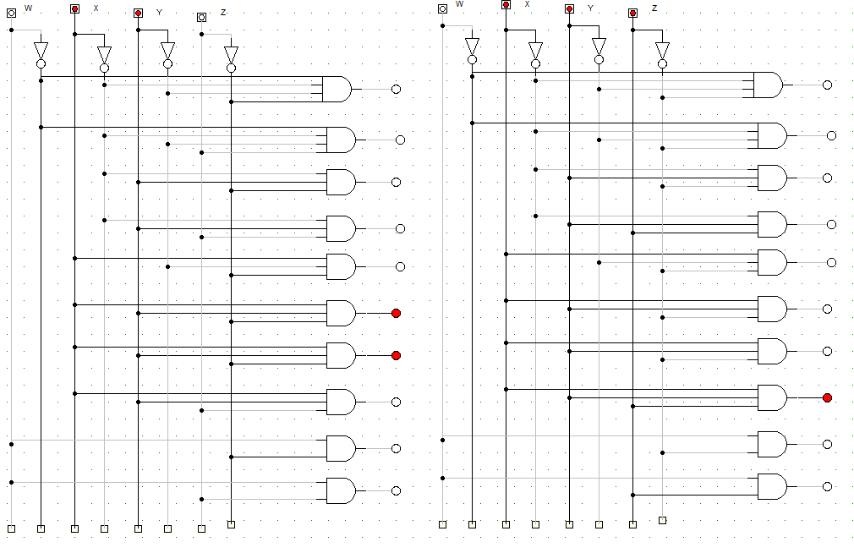

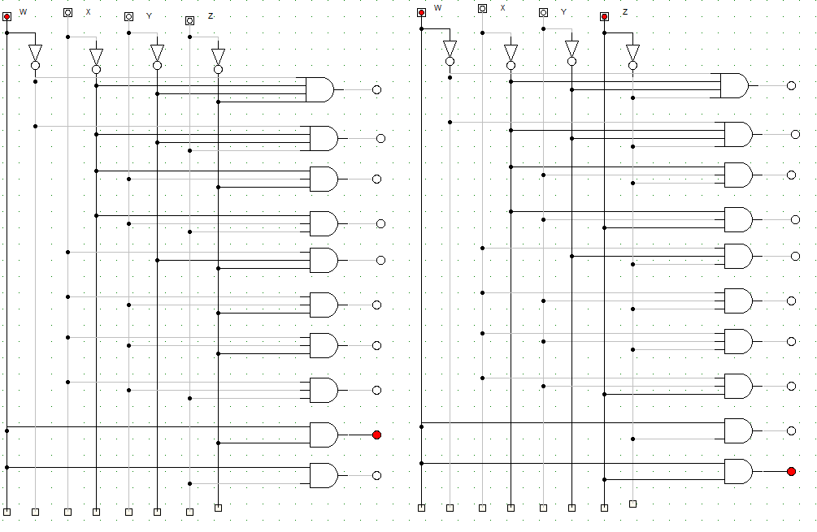

**OBSERVATION TABLE:**

|  |  |  |  |  |  |  |  |  |  |  |  |  |  |
| --- | --- | --- | --- | --- | --- | --- | --- | --- | --- | --- | --- | --- | --- |
| BCD | | | | Decimal | | | | | | | | | |
| W | **X** | **Y** | **Z** | **D0** | **D1** | **D2** | **D3** | **D4** | **D5** | **D6** | **D7** | **D8** | **D9** |
| 0 | 0 | 0 | 0 | 1 | 0 | 0 | 0 | 0 | 0 | 0 | 0 | 0 | 0 |
| 0 | 0 | 0 | 1 | 0 | 1 | 0 | 0 | 0 | 0 | 0 | 0 | 0 | 0 |
| 0 | 0 | 1 | 0 | 0 | 0 | 1 | 0 | 0 | 0 | 0 | 0 | 0 | 0 |
| 0 | 0 | 1 | 1 | 0 | 0 | 0 | 1 | 0 | 0 | 0 | 0 | 0 | 0 |
| 0 | 1 | 0 | 0 | 0 | 0 | 0 | 0 | 1 | 0 | 0 | 0 | 0 | 0 |
| 0 | 1 | 0 | 1 | 0 | 0 | 0 | 0 | 0 | 1 | 0 | 0 | 0 | 0 |
| 0 | 1 | 1 | 0 | 0 | 0 | 0 | 0 | 0 | 0 | 1 | 0 | 0 | 0 |
| 0 | 1 | 1 | 1 | 0 | 0 | 0 | 0 | 0 | 0 | 0 | 1 | 0 | 0 |
| 0 | 0 | 0 | 0 | 0 | 0 | 0 | 0 | 0 | 0 | 0 | 0 | 1 | 0 |
| 1 | 0 | 0 | 1 | 0 | 0 | 0 | 0 | 0 | 0 | 0 | 0 | 0 | 1 |
| A-F Don’t care | | | | | | | | | | | | | |

**CONCLUSION:**

Hence, the operation of BCD to Decimal Decoder was verified.